PART 2: THE BOUNCER TRAINING MANUAL

SECTION 2A — TACTICAL REVIEW: The Elite Security Units
The Adaptive Immune System is triggered when pathogens invade the body, and innate defenses are activated. In contrast to the innate immunity, adaptive immunity is specific - it gets to know the unique identity signs (antigens) of each pathogen and develops permanent memory to them. Two elite lymphocyte units head this response:

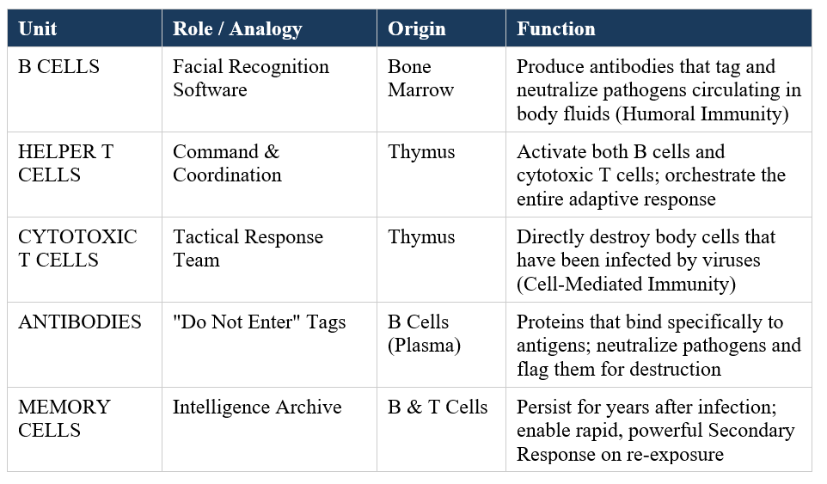

SECTION 2B — VISUAL FLOWCHART: Secondary Line of Defense
The figure below illustrates the mechanisms of B cells (Humoral arm) and T cells (Cell-mediated arm) acting in parallel to eliminate a pathogen after it enters the body. The Memory cells are on file permanently in both arms:

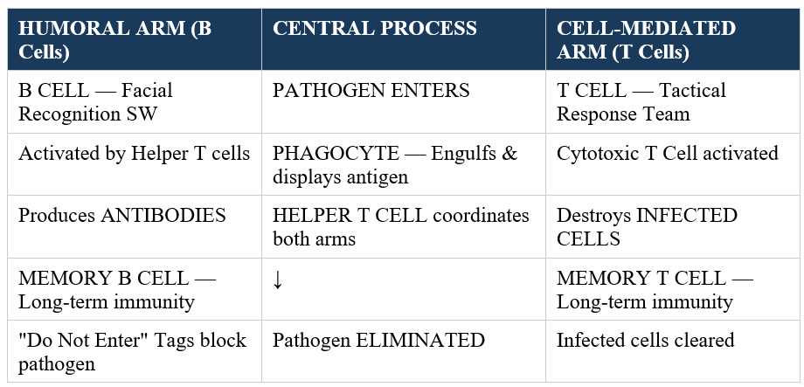

SECTION 2C — WHY THE SECOND PERFORMANCE IS FASTER & STRONGER
Immunological memory is the most important innovation of adaptive immunity. The initial response to a pathogen (Primary Response) is slow - the body has to recognize the danger, starting with nothing. But Memory cells formed by that initial response enable the second contact (Secondary Response) to be virtually immediate:

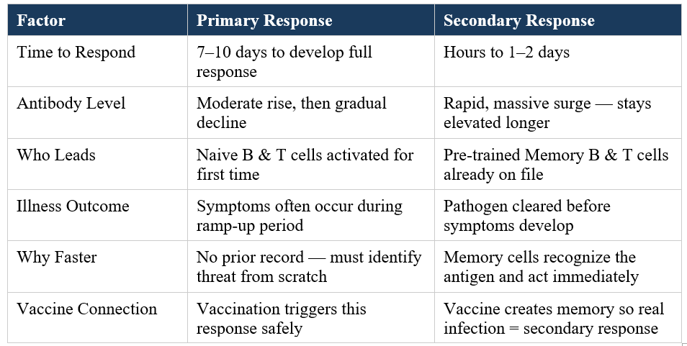

Vaccine Logic: A flu shot has attenuated/ killed viral antigens. This provokes the Primary Response without being sick, forming Memory cells. When the actual virus enters later, the body initiates an instant Secondary Response, which overpowers the virus before you get ill.

