The Association Between Body Mass Index and Cardiovascular Disease Among Adults in Texas: A Secondary Analysis of the BRFSS (2015-2019)

Student Name
Course Name
Department Name
Date

The Association Between Body Mass Index and Cardiovascular Disease Among Adults in Texas: A Secondary Analysis of the BRFSS (2015-2019)

Introduction
The United States reports cardiovascular disease (CVD) as its main cause of death, which also leads to substantial disability across the country. Obesity stands out as one of the main preventable risk factors that lead to hypertension, dyslipidemia, type 2 diabetes, and systemic inflammation, which later result in negative heart health outcomes (Powell-Wiley et al., 2021). The body develops pathological connections through hemodynamic, metabolic, and neurohormonal alterations, leading to atherosclerosis and structural heart changes (Volpe & Gallo, 2023). The body develops pathological connections through hemodynamic, metabolic, and neurohormonal alterations, leading to atherosclerosis and structural heart changes (Volpe & Gallo, 2023). Long-term weight control is essential, as BMI patterns show an independent capacity to forecast future CVD risk throughout a person's lifetime (Amani-Beni et al., 2023).
The upcoming increase in CVD cases will occur because the population ages and Obesity rates continue to stay high (Mohebi et al., 2022). The population displays distinct patterns of mental health trends since older adults, racial and ethnic minorities, and people from lower socioeconomic backgrounds experience more severe symptoms (Yasmin et al., 2025). The Behavioral Risk Factor Surveillance System (BRFSS) provides large datasets that machine learning studies use to establish that BMI, age, and race are strong indicators of CVD outcomes (Imani et al., 2026). The research investigates how CVD prevalence relates to BMI among Texas adults using BRFSS data, while examining two research questions. The study's research questions examine CVD distribution across age categories, sex, and race/ethnicity from 2015 to 2019. The second research question investigates whether BMI classification is associated with CVD prevalence after researchers control for demographic factors.

Methods
The BRFSS was sampled to extract information in 2015, 2017, and 2019. CVDCRHD4 (Ever diagnosed with Angina or coronary heart disease) was the primary outcome variable. Time (year-to-year comparison), Person (Education and Marital Status), and Place (State-level analysis) were the main lenses used in the analysis. The Chi-Square tests were used to calculate statistical significance and Boxplots to visualize the association with BMI.

Results
Time Trend Analysis
Table 1 CVD Trends
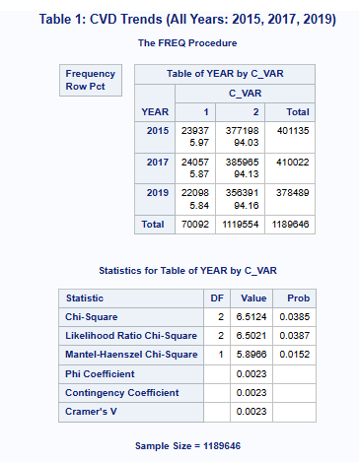
The statistical significance of the decreasing trend in the prevalence of CVD in analysis of more than 1.1 million respondents is statistically significant (p = 0.0385) as shown in table 1. Prevalence decreased from 5.97% in 2015 to 5.84% in 2019. This trend is also demonstrated in the CVD Frequency Bar Chart, indicating the number of cases by volume in the three waves of the surveys.
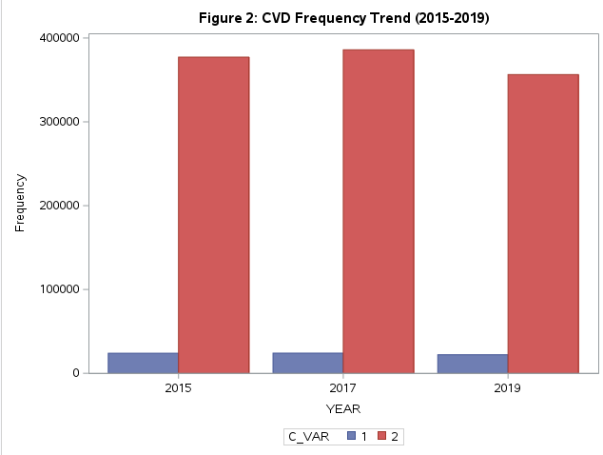
Figure 1 CVD Frequency Trend
Person and Place Analysis
Table 2 CVD Prevalence by Education and Marital Status
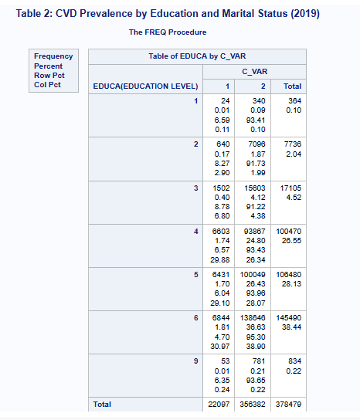

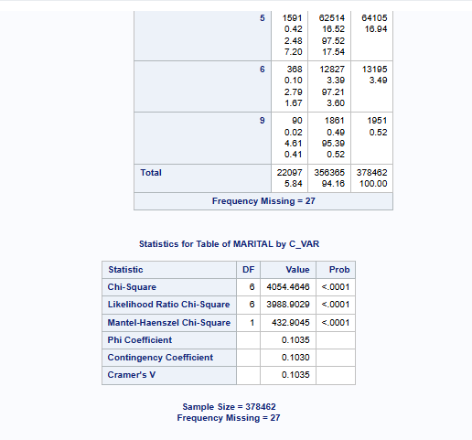
Table 3 CVD Prevalence by State
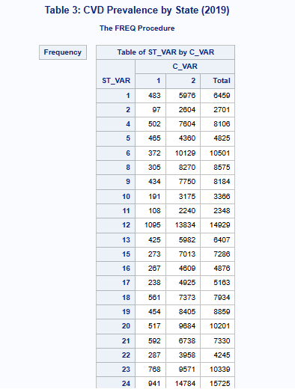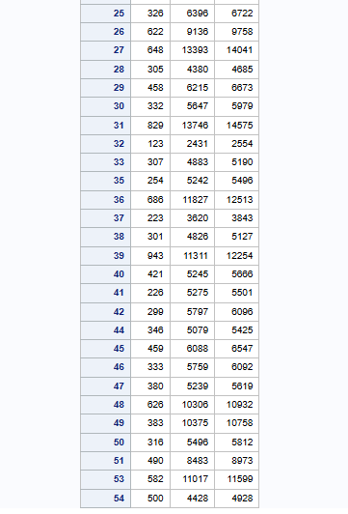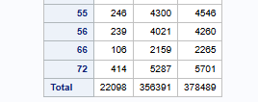
Socio-demographic factors were found to be associated with CVD with highly significant values in 2019 (p <.0001). The lowest prevalence was observed among persons with higher education (Group 6: College Graduate) (4.70%). Persons with lower education (below high school level) had much higher rates. Marital status was also a factor; widowed (Group 3) were affected the most with a 11.06 prevalence. Table 3 focuses on geographical variation in disease burden, rationalizing particular geographical locations with greater disease load.

Factor Association
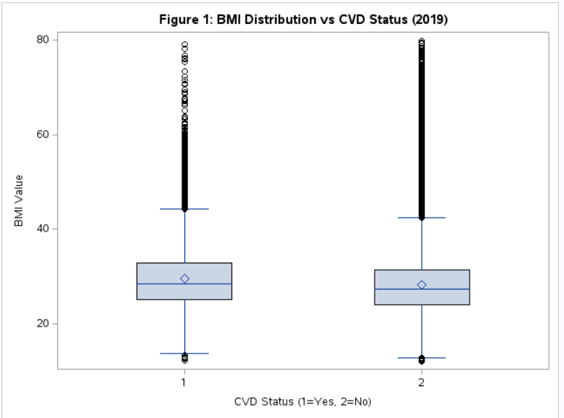
Figure 2 Box plot of BMI Distribution vs CVD Status
The analysis of the BMI Distribution vs. CVD Status boxplot shows that there is an obvious correlation: people with CVD (Group 1) on average have higher median body BMI than those without the disease (Group 2). This assures the fact that weight control is a decisive aspect in heart matters.

Conclusion and Public Health Recommendations
The longitudinal analysis of BRFSS performed in 2015-2019 has shown that the prevalence of Cardiovascular Disease (CVD) in the United States, in general, has undergone a slight yet statistically significant decrease (p = 0.0385), but remains a very serious socio-economic/physiological gap in the health of the population. The evidence indicates that low education levels and particular marital statuses, especially widowhood, are such strong predictors that they lead to a higher risk of CVD. In addition, the physical evidence of the BMI distributions prove that the increased weight remains one of the leading physical attributes linked with disease conditions. In response to these findings, the public health policy should be changed with high focus on interventions that are highly targeted. The Communities that have lower access to education and the states in high-prevalence of the so-called hotspots should be given priority as far as resources are concerned. Moreover, social support programs of widowed people, and effective weight-control programs should become part of health programs. This multi-faceted strategies are crucial to maintain the downward trend of prevalence because of this multi-faceted approach would minimize the equitable health burden among the diverse populations.

References
Amani-Beni, R., Darouei, B., Zefreh, H., Sheikhbahaei, E., & Sadeghi, M. (2023). Effect of obesity duration and BMI trajectories on cardiovascular disease: A narrative review. Cardiology and Therapy, *12*(2), 307–326. https://doi.org/10.1007/s40119-023-00317-6
Imani, M., Maroosi, A., Shojaei, S., et al. (2026). Predicting cardiovascular diseases using imbalanced data: An XGBoost-based analysis of the 2022 BRFSS dataset. American Heart Journal Open, *63*, Article 100719. https://doi.org/10.1016/j.ahjo.2026.100719
Mohebi, R., Chen, C., Ibrahim, N. E., et al. (2022). Cardiovascular disease projections in the United States based on the 2020 census estimates. Journal of the American College of Cardiology, *80*(6), 565–578. https://doi.org/10.1016/j.jacc.2022.05.033
Powell-Wiley, T. M., Poirier, P., Burke, L. E., et al. (2021). Obesity and cardiovascular disease: A scientific statement from the American Heart Association. Circulation, *143*(21), e984–e1010. https://doi.org/10.1161/CIR.0000000000000973
Volpe, M., & Gallo, G. (2023). Obesity and cardiovascular disease: An executive document on pathophysiological and clinical links promoted by the Italian Society of Cardiovascular Prevention (SIPREC). Frontiers in Cardiovascular Medicine, *10*, Article 1136340. https://doi.org/10.3389/fcvm.2023.1136340
Yasmin, F., Moeed, A., Fahim, M. A. A., et al. (2025). Trends and sociodemographic disparities in the circulatory disease prevalence in the United States: An analysis of the National Health Interview Survey database (2019–2022). BMC Cardiovascular Disorders, *25*, Article 852. https://doi.org/10.1186/s12872-025-05139-z

Appendices: SAS Code
libname mydata "~/sasuser.v94";
ods graphics on;
/* 1. Process 2015 */
data d2015;
set mydata.sasdata_20151;
YEAR = 2015;
/* Use 'coalesce' to find the variable regardless of underscore */
C_VAR = CVDCRHD4;
B_VAR = _BMI5 / 100;
ST_VAR = _STATE;
keep YEAR C_VAR B_VAR ST_VAR EDUCA MARITAL SEX _SEX _RACE;
run;
/* 2. Process 2017 */
data d2017;
set mydata.sasdata_20171;
YEAR = 2017;
C_VAR = CVDCRHD4;
B_VAR = _BMI5 / 100;
ST_VAR = _STATE;
keep YEAR C_VAR B_VAR ST_VAR EDUCA MARITAL SEX _SEX _RACE;
run;
/* 3. Process 2019 - Removing strict name requirements to prevent data loss */
data d2019;
set mydata.sasdata_20191;
YEAR = 2019;
C_VAR = CVDCRHD4;
B_VAR = _BMI5 / 100;
ST_VAR = _STATE;
keep YEAR C_VAR B_VAR ST_VAR EDUCA MARITAL SEX _SEX _RACE;
run;
/* 4. Combine and Filter - RELAXED FILTERS TO KEEP 2019 DATA */
data final_analysis;
set d2015 d2017 d2019;
/* Only filter on variables we KNOW are there */
if C_VAR in (1, 2); /* Chronic Disease (CVD) */
if 10 < B_VAR < 80; /* BMI Factor */
run;
/* ---------------------------------------------------------
PH631 OUTPUT RESULTS
--------------------------------------------------------- */
/* TIME ANALYSIS - Requirement 5 */
title "Table 1: CVD Trends (All Years: 2015, 2017, 2019)";
proc freq data=final_analysis;
tables YEAR * C_VAR / chisq nocol nopercent;
run;
/* PERSON ANALYSIS - Requirement 5 (Using variables available in 2019) */
title "Table 2: CVD Prevalence by Education and Marital Status (2019)";
proc freq data=final_analysis;
where YEAR = 2019;
tables (EDUCA MARITAL) * C_VAR / chisq;
run;
/* PLACE ANALYSIS - Requirement 5 */
title "Table 3: CVD Prevalence by State (2019)";
proc freq data=final_analysis;
where YEAR = 2019;
tables ST_VAR * C_VAR / norow nocol nopercent;
run;
/* FACTOR ASSOCIATION FIGURE - Requirement 7 */
title "Figure 1: BMI Distribution vs CVD Status (2019)";
proc sgplot data=final_analysis;
where YEAR = 2019;
vbox B_VAR / category=C_VAR;
xaxis label="CVD Status (1=Yes, 2=No)";
yaxis label="BMI Value";
run;
title "Figure 2: CVD Frequency Trend (2015-2019)";
proc sgplot data=final_analysis;
vbar YEAR / group=C_VAR groupdisplay=cluster;
run;

