Assignment 10

Timmy Akintade
Western Kentucky
PH631
Xihua Ding
4/20/26

Assignment 10
- What is the crude prevalence of hypertension (_RFHYPE5) based on the data?
According to the data, the crude prevalence of hypertension was 58.94%. It was computed out of a total population of 380,942 people, of who 224,525 were found to have hypertension.
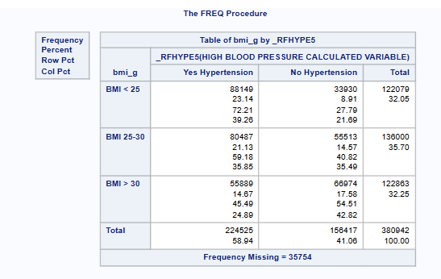
- What is the crude prevalence of hypertension by different BMI categories (bmi_g) in the dataset?
In the analysis of the prevalence of hypertension in the three BMI groups, the three groups were found to be different. The incidence of hypertension was 72.21% among people with a BMI lower than 25. The prevalence in those with a BMI between 25 and 30 was 59.18% and in those with a BMI greater than 30, the prevalence was 45.48%. These figures are based on the percentages in the row of the crosstab output. It should also be noted that the observed higher prevalence in the lower BMI group could be due to the influence of age or other confounding factors that are present in the data as this pattern is counterintuitive to what is commonly clinically expected.
- Is there any association between BMI and the prevalence of hypertension? If so, what is the measure of association, and how should it be interpreted?
Yes, statistically significant relationship exists between BMI category and prevalence of hypertension. The Pearson Chi-Square test provides a value of 18,067.06 with 2 degrees of freedom and a p-value of less than 0.0001 which means that we reject the null hypothesis of no association. The measure of association in this case was Cramer’s V which was 0.2178. This shows that there is a weak to medium correlation between BMI category and hypertension status. That is, although the correlation between the category of BMI and the occurrence of hypertension is statistically significant due to the large sample size, the practical strength of the relationship between the category of BMI and the occurrence of hypertension is relatively modest.
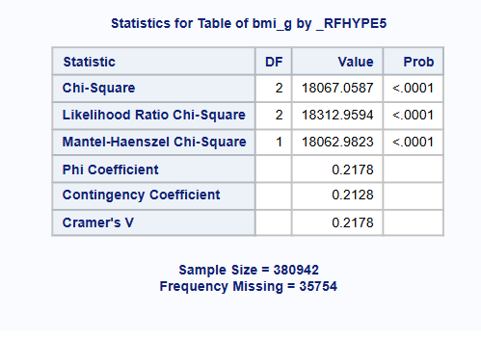

Appendix
Codes
libname brfss "/home/u64346043/sasuser.v94/";

data sasdata_20191;
set brfss.sasdata_20191;
if _BMI5 = . then bmi_g = .;
else if _BMI5 < 2500 then bmi_g = 1; /* BMI less than 25 */
else if 2500 <= _BMI5 < 3000 then bmi_g = 2; /* BMI between 25 and 30 */
else if _BMI5 >= 3000 then bmi_g = 3; /* BMI greater than 30 */
run;

proc format;
value bmi_fmt
1 = "BMI < 25"
2 = "BMI 25-30"
3 = "BMI > 30";
value hype_fmt
1 = "Yes Hypertension"
2 = "No Hypertension";
run;

proc freq data = sasdata_20191 (where = (_RFHYPE5 < 7));
tables bmi_g * _RFHYPE5 / chisq;
format bmi_g bmi_fmt. _RFHYPE5 hype_fmt.;
run;

