Final Project

[STUDENT NAME]
[COURSE NAME AND NUMBER]
[INSTRUCTOR'S NAME]
[INSTITUTIONAL AFFILIATION]
[SUBMISSION DATE]

Final Project
Diabetes mellitus is one of the biggest challenges for the US health care system. It is a serious burden on the individual, in terms of complications such as cardiovascular disease, renal failure and neuropathy, and the health care system. Body mass index (BMI) has been shown to be one of the strongest risk factors for type 2 diabetes (Deng et al., 2025). Obese individuals have a greater risk of diabetes than individuals of normal weight. The current study will explore the prevalence and trends of diabetes among U.S. adults from 2015 to 2019 using BRFSS data and the relationship between body mass index (BMI) and diabetes.
Review of Literature
In recent years, diabetes mellitus has been widely researched and there is increasing evidence of its prevalence in the United States and worldwide. In a national analysis of diabetes trends using BRFSS data, Okorigba et al. (2025) noted consistently high prevalence among older adults and racial minorities, and called for strategies to address this. Fang et al. (2021) showed that obesity (calculated as BMI) was the most significant modifiable risk factor for type 2 diabetes, with obese people almost three times as likely to develop type 2 diabetes as people of healthy weight. Mikhail et al. (2021) also validated considerable racial and ethnic differences in diabetes prevalence, with higher prevalence among Black and Hispanics than White Non-Hispanics. In terms of sex differences, Yan et al. (2023) found that the prevalence of diabetes was significantly higher in females in older age groups, implying that hormonal and socioeconomic factors play a role in risk. Finally, Zhou et al. (2024) recently performed a systematic review, confirming that over time, maintaining a high BMI significantly elevates the risk of developing type 2 diabetes, suggesting BMI is an important target for prevention.
Methods
Data Source and Study Design
For this analysis, data were from the Behavioral Risk Factor Surveillance System (BRFSS), a cross-sectional, nationally representative telephone survey conducted each year. The BRFSS includes information on health-related risk factors, chronic diseases, and use of preventive services for non-institutionalized U.S. adults aged 18 years and older. Data from three survey years were used (2015, 2017 and 2019; equivalent to sasdata_20151, sasdata_20171 and sasdata_20191).
Study Population
A total of 1,309,740 respondents were included in the analyses across the three years. The prevalence analyses excluded respondents with missing or refused values for diabetes.
Outcome Variable
The key variable of interest was diabetes status. It was assessed using DIABETE3 in the 2015 and 2017 survey data and DIABETE4 in 2019. Those who reported that a doctor had told them that they had diabetes were coded as having diabetes (1=Yes). Respondents who reported they did not have diabetes or only pre-diabetes were classified as not having diabetes (0=No). All other responses (refused, don't know) were classified as missing.
Exposure and Covariates
The main exposure variable was weight in terms of body mass index (BMI) which was calculated by dividing the continuous variable _BMI5 by 100. BMI was defined using the following categories: underweight (less than 18.5), normal weight (18.5-24.9), overweight (25.0-29.9) and obese (greater than 30.0).
Demographic variables included sex (male/female), age (18-24, 25-34, 35-44, 45-54, 55-64, 65 and older) and race/ethnicity (White Non-Hispanic, Black Non-Hispanic, American Indian/Alaskan Native, Asian Non-Hispanic, Native Hawaiian/Pacific Islander, Other Race, Multiracial, and Hispanic). These variables were derived from the variables SEX, _AGE_G and _RACE.
Statistical Analysis
Descriptive statistics including frequencies and percentages were calculated to examine diabetes prevalence across survey years, sex, age groups, and race/ethnicity. The chi-square test was applied to examine the significance of the association between diabetes and each demographic category and BMI category. Data were analyzed using SAS OnDemand for Academics.
Results
Sample Characteristics
A total of 1,309,740 survey respondents across three years were included in the analysis. The 2017 survey contributed the largest proportion of respondents (450,016; 34.36%), followed by 2015 (441,456; 33.71%) and 2019 (418,268; 31.94%). Of the overall sample with valid responses to the diabetes question, 175,097 (13.50%) were categorized as having diabetes and 1,121,530 (86.50%) were categorized as not having diabetes.
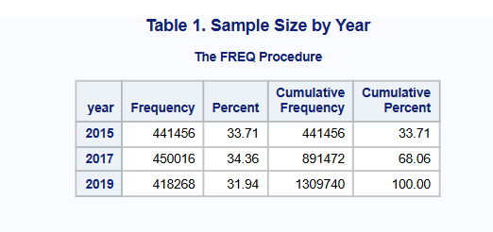
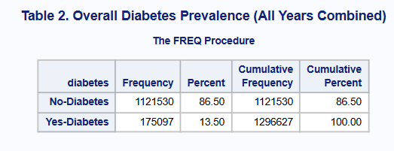
Time Trends in Diabetes Prevalence
There was some variation in diabetes prevalence across the three years of the survey. During 2015, 57,256 (4.42%) were classified as having diabetes. Prevalence rose slightly in 2017 to 60,440 (4.66%), before returning to 57,401 (4.43%) in 2019. While the difference was minor, the positive change in prevalence between 2015 and 2017 may indicate a slight increase in diabetes prevalence, which is important to monitor from a public health perspective.

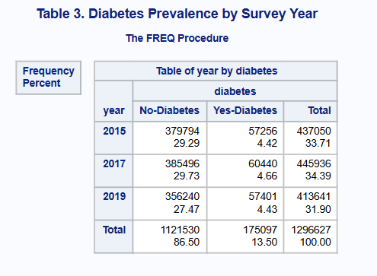

Person Analysis
Sex
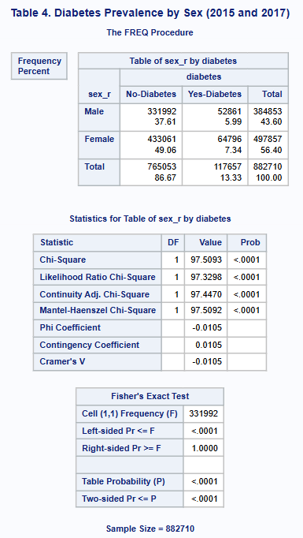
In 2015 and 2017, females had a higher prevalence of diabetes than males (7.34% vs 5.99%, respectively). This was statistically significant (Chi-square p<.0001), suggesting that females were more likely to have diabetes than males.

Age Group
The prevalence of diabetes was positively associated with age. The age group with the lowest prevalence was 18-24 years (0.06%) and the highest was 65 years or more (7.49%). This age effect was significant (Chi-square p<.0001), and demonstrates that older adults have a higher burden of diabetes.
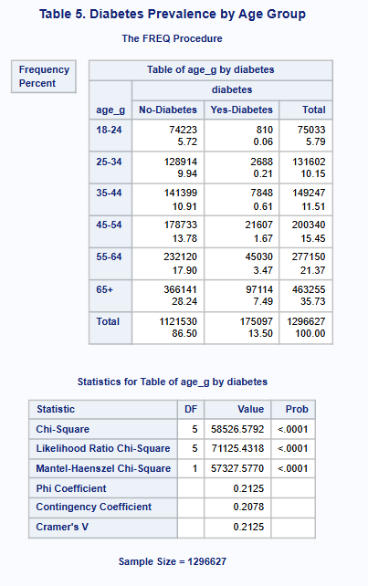
Race/Ethnicity
There were also marked variation in diabetes prevalence across racial/ethnic groups (Chi-square p<.0001). Black Non-Hispanic respondents had the highest prevalence (1.63%) followed by Hispanics (1.23%). White Non-Hispanic respondents had the greatest number of respondents (9.84%) in absolute numbers. This shows ongoing racial and ethnic inequalities in diabetes.
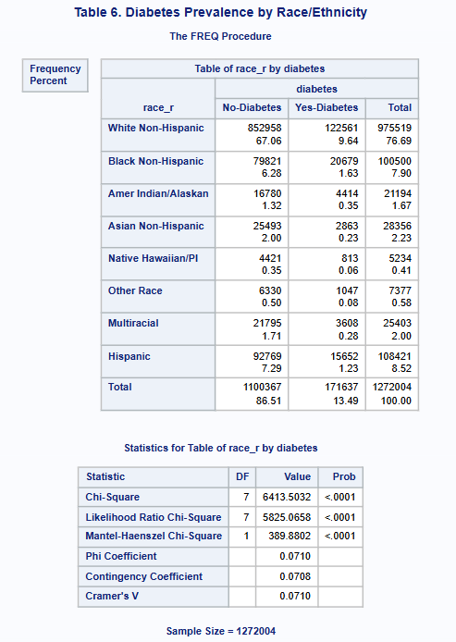
Association between BMI and Diabetes
There was a strong and significant association between obesity and diabetes (Chi-square p<.0001). The proportion of respondents who were obese and had diabetes was 7.26% compared to 0.08% among those who were underweight and 1.91% among those who had normal weight. This association remained similar across all three years of the survey, as indicated in the stratification analysis. The average BMI among respondents with diabetes was 31.70 while that of respondents without diabetes was 27.62, clearly showing the association between BMI and diabetes.
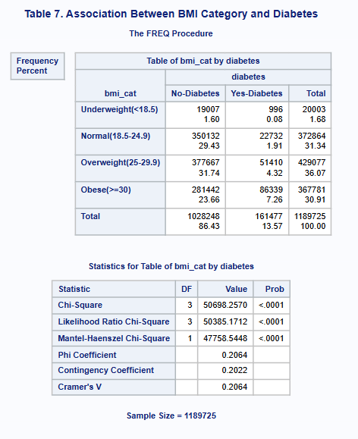

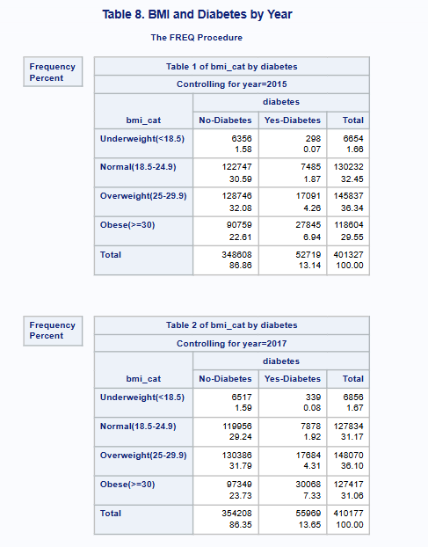

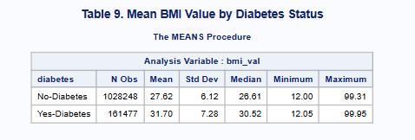
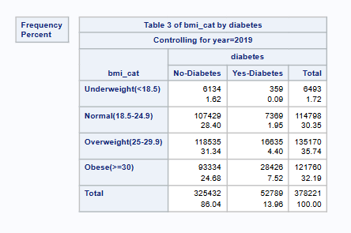

Conclusion
The aim of this study was to explore the prevalence and relationship between diabetes and BMI in the adult U.S. population using BRFSS data from 2015, 2017 and 2019. It found that diabetes prevalence was consistently high across the three years of the survey, with 13.50% of the analytic sample having diabetes. Time trend analysis revealed that prevalence slightly increased from 2015 to 2017 and then decreased in 2019, indicating progress is being made but diabetes is still a major public health challenge. The person analysis revealed that diabetes prevalence was higher in females, increased with age and varied by race and ethnicity, being disproportionately higher in Blacks (Non-Hispanic) and Hispanics. Crucially, a significant and statistically significant association between BMI and diabetes was observed, with obesity prevalence being substantially higher than in all other BMI groups. These results are in line with previous literature establishing BMI as a key modifiable risk factor for developing type 2 diabetes.
Public Health Recommendations
Given these results, the following recommendations are made. First, programs for obesity prevention and weight control should be a priority, especially in areas where obesity is prevalent. Second, diabetes screening and early detection programs should be enhanced in the 55+ age group given the high age gradient of obesity and diabetes. Third, culturally sensitive programs should be implemented for Black Non-Hispanic and Hispanic communities to address the high diabetes prevalence in these communities. Finally, community- and nationally-based media campaigns should be maintained and scaled up to promote optimal diet and physical activity to combat the underlying factors driving the increase in BMI and diabetes.

References
Deng, L., Jia, L., Wu, X.-L., & Cheng, M. (2025). Association Between Body Mass Index and Glycemic Control in Type 2 Diabetes Mellitus: A Cross-Sectional Study. Diabetes, Metabolic Syndrome and Obesity, 18, 555–563. https://doi.org/10.2147/DMSO.S508365
Fang, M., Wang, D., Coresh, J., & Selvin, E. (2021). Trends in Diabetes Treatment and Control in U.S. Adults, 1999-2018. The New England Journal of Medicine, 384(23), 2219–2228. https://doi.org/10.1056/NEJMsa2032271
Mikhail, N., Wali, S., & Brown, A. F. (2021). Ethnic disparities in diabetes. Endocrinology and Metabolism Clinics of North America, 50(3), 475–490. https://doi.org/10.1016/j.ecl.2021.05.006
Okorigba, E., Akinade, O., Emore, E., Adebayo, A., Aghale, O., Ekarika, E., Awuji, K., Olawale, O., Siaw, T., Azipu, R., & Okobi, O. (2025). Prevalence and Hospitalization Trends of Cardiovascular Disease in Diabetic Populations: An Analysis of the United States Diabetes Surveillance System (USDSS) Data From 2000 to 2022. Cureus, 17. https://doi.org/10.7759/cureus.87886
Yan, Z., Cai, M., Han, X., Chen, Q., & Lu, H. (2023). The Interaction Between Age and Risk Factors for Diabetes and Prediabetes: A Community-Based Cross-Sectional Study. Diabetes, Metabolic Syndrome and Obesity, 16, 85–93. https://doi.org/10.2147/DMSO.S390857
Zhou, B., Rayner, A. W., Gregg, E. W., Sheffer, K. E., Carrillo-Larco, R. M., Bennett, J. E., Shaw, J. E., Paciorek, C. J., Singleton, R. K., Pires, A. B., Stevens, G. A., Danaei, G., Lhoste, V. P., Phelps, N. H., Heap, R. A., Jain, L., Brisis, Y. D. D., Galeazzi, A., Kengne, A. P., … Ezzati, M. (2024). Worldwide trends in diabetes prevalence and treatment from 1990 to 2022: A pooled analysis of 1108 population-representative studies with 141 million participants. The Lancet, 404(10467), 2077–2093. https://doi.org/10.1016/S0140-6736(24)02317-1

Appendix
SAS Code
libname brfss "/home/u64346043/sasuser.v94";

/*
STEP 1: PREPARE 2015 DATA
*/

data diabetes_2015;
set brfss.sasdata_20151;

seqno_c = put(SEQNO, 20.);

if DIABETE3 = 1 then diabetes = 1;
else if DIABETE3 in (3,4) then diabetes = 0;
else diabetes = .;

bmi_val = _BMI5 / 100;
if bmi_val = . then bmi_cat = .;
else if bmi_val < 18.5 then bmi_cat = 1;
else if bmi_val < 25.0 then bmi_cat = 2;
else if bmi_val < 30.0 then bmi_cat = 3;
else if bmi_val >= 30.0 then bmi_cat = 4;

if SEX = 1 then sex_r = 1;
else if SEX = 2 then sex_r = 2;
else sex_r = .;

if _AGE_G in (1,2,3,4,5,6) then age_g = _AGE_G;
else age_g = .;

if _RACE in (1,2,3,4,5,6,7,8) then race_r = _RACE;
else race_r = .;

year = 2015;

keep seqno_c diabetes bmi_val bmi_cat sex_r age_g race_r year;

run;

/*
STEP 2: PREPARE 2017 DATA
*/

data diabetes_2017;
set brfss.sasdata_20171;

seqno_c = put(SEQNO, 20.);

if DIABETE3 = 1 then diabetes = 1;
else if DIABETE3 in (3,4) then diabetes = 0;
else diabetes = .;

bmi_val = _BMI5 / 100;
if bmi_val = . then bmi_cat = .;
else if bmi_val < 18.5 then bmi_cat = 1;
else if bmi_val < 25.0 then bmi_cat = 2;
else if bmi_val < 30.0 then bmi_cat = 3;
else if bmi_val >= 30.0 then bmi_cat = 4;

if SEX = 1 then sex_r = 1;
else if SEX = 2 then sex_r = 2;
else sex_r = .;

if _AGE_G in (1,2,3,4,5,6) then age_g = _AGE_G;
else age_g = .;

if _RACE in (1,2,3,4,5,6,7,8) then race_r = _RACE;
else race_r = .;

year = 2017;

keep seqno_c diabetes bmi_val bmi_cat sex_r age_g race_r year;

run;

/*
STEP 3: PREPARE 2019 DATA
*/

data diabetes_2019;
set brfss.sasdata_20191;

seqno_c = put(SEQNO, 20.);

if DIABETE4 = 1 then diabetes = 1;
else if DIABETE4 in (3,4) then diabetes = 0;
else diabetes = .;

bmi_val = _BMI5 / 100;
if bmi_val = . then bmi_cat = .;
else if bmi_val < 18.5 then bmi_cat = 1;
else if bmi_val < 25.0 then bmi_cat = 2;
else if bmi_val < 30.0 then bmi_cat = 3;
else if bmi_val >= 30.0 then bmi_cat = 4;

sex_r = .;

if _AGE_G in (1,2,3,4,5,6) then age_g = _AGE_G;
else age_g = .;

if _RACE in (1,2,3,4,5,6,7,8) then race_r = _RACE;
else race_r = .;

year = 2019;

keep seqno_c diabetes bmi_val bmi_cat sex_r age_g race_r year;

run;

/*
STEP 4: COMBINE ALL THREE YEARS
*/

data diabetes_all;
set diabetes_2015 diabetes_2017 diabetes_2019;
run;

/*
STEP 5: FORMATS
*/

proc format;
value diabfmt
1 = "Yes-Diabetes"
0 = "No-Diabetes";

value sexfmt
1 = "Male"
2 = "Female";

value agefmt
1 = "18-24"
2 = "25-34"
3 = "35-44"
4 = "45-54"
5 = "55-64"
6 = "65+";

value racefmt
1 = "White Non-Hispanic"
2 = "Black Non-Hispanic"
3 = "Amer Indian/Alaskan"
4 = "Asian Non-Hispanic"
5 = "Native Hawaiian/PI"
6 = "Other Race"
7 = "Multiracial"
8 = "Hispanic";

value bmifmt
1 = "Underweight(<18.5)"
2 = "Normal(18.5-24.9)"
3 = "Overweight(25-29.9)"
4 = "Obese(>=30)";
run;

/*
STEP 6: OVERALL SAMPLE SIZE BY YEAR
*/

title "Table 1. Sample Size by Year";
proc freq data=diabetes_all;
tables year;
run;

/*
STEP 7: OVERALL DIABETES PREVALENCE
*/

title "Table 2. Overall Diabetes Prevalence (All Years Combined)";
proc freq data=diabetes_all;
where diabetes ne .;
tables diabetes;
format diabetes diabfmt.;
run;

/*
STEP 8: TIME ANALYSIS - Diabetes by Year
*/

title "Table 3. Diabetes Prevalence by Survey Year";
proc freq data=diabetes_all;
where diabetes ne .;
tables year * diabetes / norow nocol;
format diabetes diabfmt.;
run;

/*
STEP 9: PERSON ANALYSIS - SEX (2015 and 2017 only)
*/

title "Table 4. Diabetes Prevalence by Sex (2015 and 2017)";
proc freq data=diabetes_all;
where diabetes ne . and sex_r ne . and year in (2015, 2017);
tables sex_r * diabetes / norow nocol chisq;
format diabetes diabfmt. sex_r sexfmt.;
run;

/*
STEP 10: PERSON ANALYSIS - AGE GROUP
*/

title "Table 5. Diabetes Prevalence by Age Group";
proc freq data=diabetes_all;
where diabetes ne . and age_g ne .;
tables age_g * diabetes / norow nocol chisq;
format diabetes diabfmt. age_g agefmt.;
run;

/*
STEP 11: PERSON ANALYSIS - RACE
*/

title "Table 6. Diabetes Prevalence by Race/Ethnicity";
proc freq data=diabetes_all;
where diabetes ne . and race_r ne .;
tables race_r * diabetes / norow nocol chisq;
format diabetes diabfmt. race_r racefmt.;
run;

/*
STEP 12: ASSOCIATION - BMI AND DIABETES
*/

title "Table 7. Association Between BMI Category and Diabetes";
proc freq data=diabetes_all;
where diabetes ne . and bmi_cat ne .;
tables bmi_cat * diabetes / norow nocol chisq;
format diabetes diabfmt. bmi_cat bmifmt.;
run;

/*
STEP 13: BMI-DIABETES BY YEAR (STRATIFIED)
*/

title "Table 8. BMI and Diabetes by Year";
proc freq data=diabetes_all;
where diabetes ne . and bmi_cat ne .;
tables year * bmi_cat * diabetes / norow nocol;
format diabetes diabfmt. bmi_cat bmifmt.;
run;

/*
STEP 14: MEAN BMI BY DIABETES STATUS
*/

title "Table 9. Mean BMI Value by Diabetes Status";
proc means data=diabetes_all mean std median min max maxdec=2;
where diabetes ne . and bmi_val ne .;
class diabetes;
var bmi_val;
format diabetes diabfmt.;
run;

title;

