Assignment 7
PH631

Q1-Draw the geographic map for adjusted prevalence of having coronary heart disease or myocardial Infarction using BRFSS dataset in 2019 and discuss the patterns over different states.

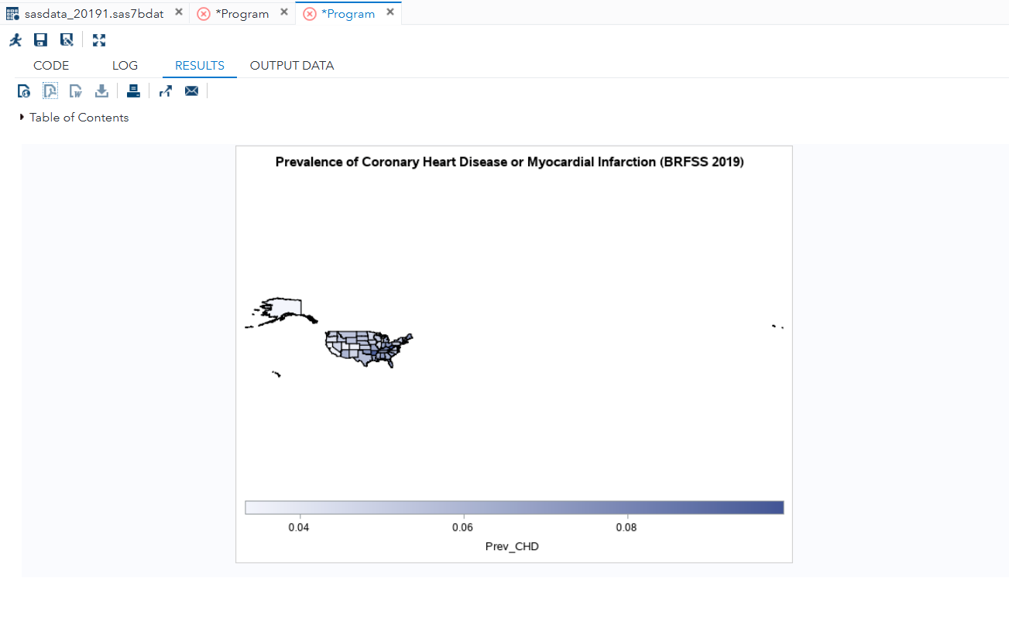
The adjusted prevalence of coronary heart disease (CHD) or myocardial infarction (MI) in the 2019 BRFSS dataset is depicted in the geographic map and displays visible regional trends in the United States. The prevalence is typically highest in the Southeastern area with such states as Mississippi, Alabama, West Virginia, Kentucky and Louisiana. This region is commonly called the Stroke Belt. These are states where the prevalence of risk factors related to cardiovascular diseases like smoking, obesity, hypertension, diabetes, and a lack of physical activities rises. Moreover, socioeconomic issues and lack of access to preventive healthcare services are other contributing factors to the increased load on heart disease in these states.
Conversely, Western and certain Northeastern states such as Colorado, Utah, California and Massachusetts tend to have lower prevalence rates. Such states tend to be having healthier lifestyles, are more physically active, have fewer smokers, and more readily to healthcare services. Cardiovascular disease risk in these regions could also be mitigated by public health programs and more vigorous health promotion programs. On the whole, a geographic pattern of CHD and MI prevalence shows that a considerable health disparity occurs across the region, with a special focus on the promotion of preventive interventions and public health strategies in the states where cardiovascular diseases impose the greatest burden.

Q2- Read the paper, titled “Obesity as an Independent Risk Factor for Cardiovascular Disease: A 26-year Follow-up of Participants in the Framingham Heart Study, and answer the following questions:
- What did they use as a measurement of obesity? How is measured? Be specific
Measurement used
The study used Metropolitan Relative Weight (MRW).
Definition
MRW =
$$\text{MRW}=\frac{\text{Actual body weight}}{\text{Desirable weight}}×100$$
Desirable weight
Taken from 1959 Metropolitan Life Insurance tables
Based on:
sex
height
medium body frame
Example
If:
Actual weight = 180 lb
Desirable weight = 150 lb
$$MRW=(180/150)×100=120$$
Meaning the person is 120% of desirable weight.
MRW categories used
Category | Interpretation
<110 | Lean
110–129 | Moderately overweight
≥130 | Obese
These categories were used to examine cardiovascular risk.

- What is the crude incidence of coronary heart disease? What are the crude incidence of coronary heart disease by women and men, respectively? Show your work that how they were estimated based on the numbers provided in the article

Numbers reported in the article
From the results:
Men at risk = 2197
Women at risk = 2714
Events of CHD:
Men = 636 cases
Women = 437 cases
Independent Risk Factor

Crude incidence (overall)
$$Incidence=\frac{\text{number of cases}}{\text{population at risk}} \\ =\frac{636+437}{2197+2714} \\ =\frac{1073}{4911} \\ =0.218$$
Crude incidence ≈ 21.8% over 26 years

Crude incidence for men
$$=\frac{636}{2197} \\ =0.289$$
≈ 28.9%

Crude incidence for women
$$=\frac{437}{2714} \\ =0.161$$
≈ 16.1%

Interpretation
CHD incidence was much higher in men than women.
Men had approximately 1.8 times higher incidence.
- Based on the results in Figure 3, create a table to show the estimated Relative Risk of coronary heart disease by the level of MRW(< 110, 110-119, >130+) and by sex and provide an interpretation of the findings.

Figure 3 provides incidence rates per 1000 people.
Approximate values from the figure:

Men (<50 years)
MRW Category | CHD incidence (per 1000) | Relative Risk
<110 | 91 | 1.0
110–129 | 128 | 128/91 = 1.41
≥130 | 183 | 183/91 = 2.01

MRW Category | CHD incidence | Relative Risk
<110 | 39 | 1.0
110–129 | 63 | 63/39 = 1.62
≥130 | 93 | 93/39 = 2.38

Sex | MRW Category | CHD Incidence | Relative Risk
Men | <110 | 91 | 1.00
Men | 110–129 | 128 | 1.41
Men | ≥130 | 183 | 2.01
Women | <110 | 39 | 1.00
Women | 110–129 | 63 | 1.62
Women | ≥130 | 93 | 2.38

Interpretation
The risk also grows with the level of obesity.
The CHD risk of people with MRW ≥130 was approximately two times higher than the risk of lean persons.
The correlation seems to be more in women.
This substantiates the research inference that obesity is an independent cardiovascular disease risk factor.

